**Student Detection and tracking**

**Ethical Consideration**

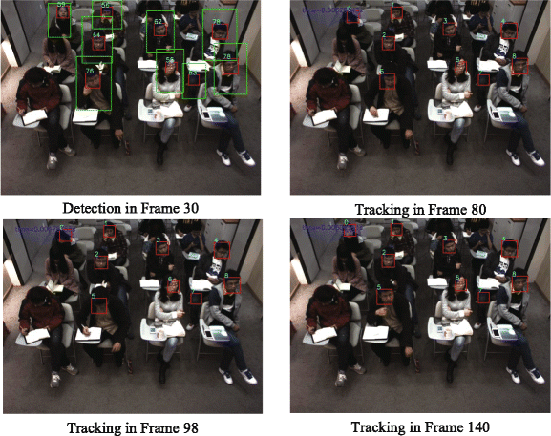

**Team 12: YEG**

**Yasser Hassan**

**Ellion Dison**

**Gabriel Young**

27 July 2022

**Social Benefit**

The most important applications of our Student Detection and tracking

are the following:

1. To see how many students are in attendance in the class and track them around.
2. To help detection during exams to see if there is any head movements through a screen to detect anyone trying to cheat.
3. It could be also used by the government to detect people in the streets during busy times of the day or for example when there is a robbery.

Any scale of teachers/professors gain the most benefit from the application of Student Detection and tracking. This application can be used as a tool to help teachers decide when and which students aren’t attending and are cheating. The nation, as a whole, also greatly benefits from Student Detection and tracking since it could be used to help track criminals across multiple cameras.

## **Bias**

A potential bias present in our model comes from the code itself. For example, one of the biggest biases that we had was that the computer camera wouldn’t detect people with darker skin complexions. Hence the model would be perceived as biased and “racist” especially in a low light/resolution place. We have a solution for it by always increasing resolution because it helps detection and having a light shining from it to help pick up darker complexions.

## **Safety**

One obvious safety concern is that people would be scared for their personal privacy because they would constantly be detected and tracked throughout the classroom and maybe in the hallways or wherever this model could be implemented. Another problem is that the model could save the data hence anything you could do would be saved by the model.

**Quality**

To help our computers track different people across the frames we had to reduce the quality of the image in each frame. We had to drop the frame from 1080p all the way to 256p per frame to help real time tracking. We could try to increase the resolution of each frame after tracking but that would result in a way much more lagged live video. Hence we just ignored increasing the resolution.

## **Principles**

Despite its critical role in the tracking and helping teachers/governments. It is important that the people in charge of the video don’t use it for malicious intent. Having people’s faces and tracking their movement could be used unethically. Hence it is a must for the people monitoring the cameras having high morals/ethics.